**Coal Lab Final Exam**

**Question # 01:**

**a.**

org 100h

mov bx,2

cmp bx,20

loop a:

jne ad

ad:

add bx,2

cmp bx,20

je loop end

ret

**b. JMP:** it’s a conditional statement use for jump from a conditional statement to another conditional statement without checking any comparison.

example:

org 100h

mov ax,3

mov bx,2

jmp ad

sub ax,1

ad:

add ax,bx

ret

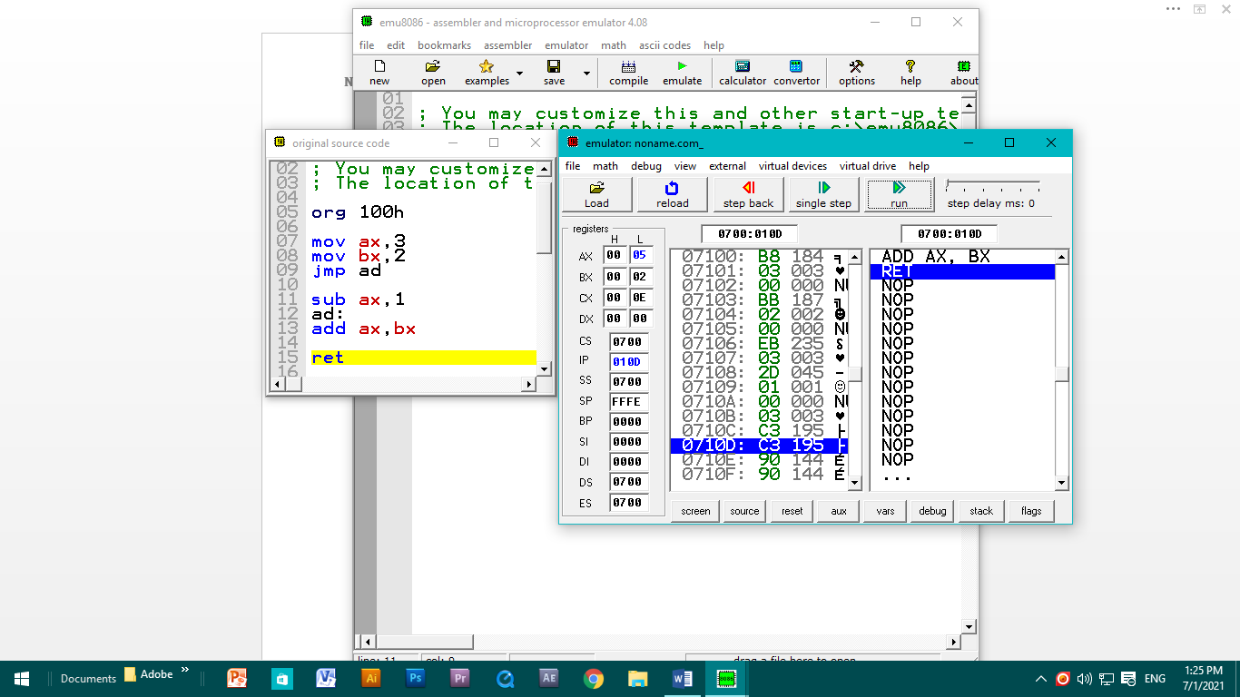

**JE:** it’s a conditional statement use for jump from a single conditional statement to another conditional statement if the comparison of register are equal.

Example:

org 100h

mov ax,3

mov bx,3

cmp ax,bx

je ad

sub ax,1

ad:

add ax,bx

ret

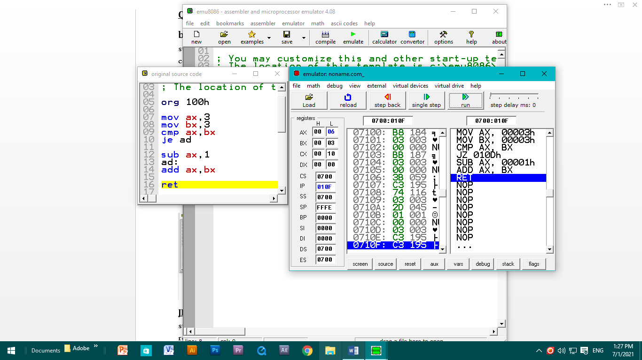

**Question # 02:**

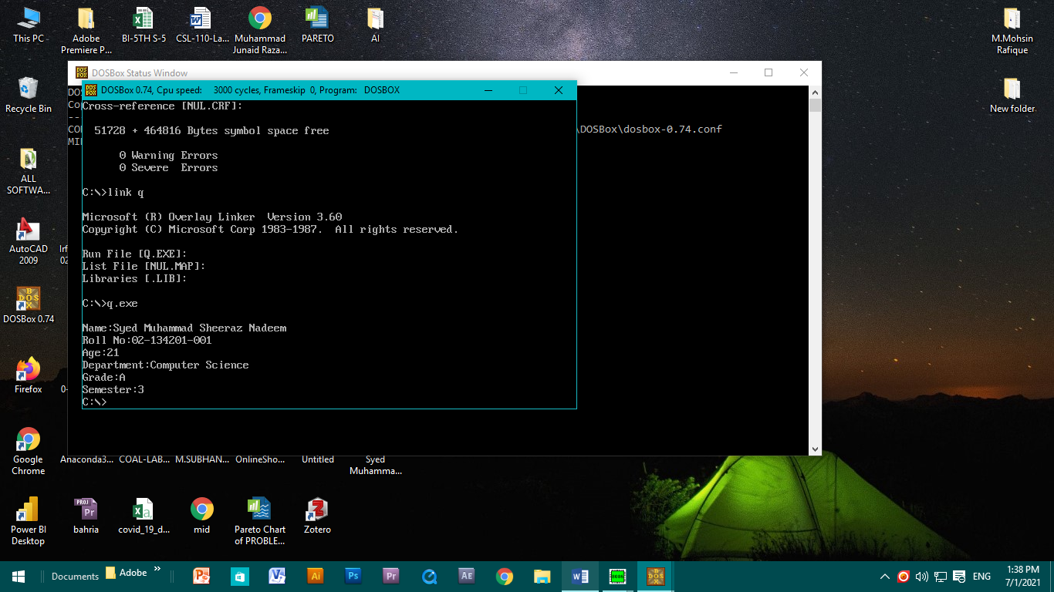

**Question # 03:**

1. code:

.MODEL SMALL

.STACK 100H

.DATA

MSG DB 'HELLO!$'

.CODE

MAIN PROC

MOV AX,@DATA

MOV DS,AX

LEA DX,MSG

MOV AH,9

INT 21H

MOV AH,1

INT 21h

MAIN ENDP

END MAIN

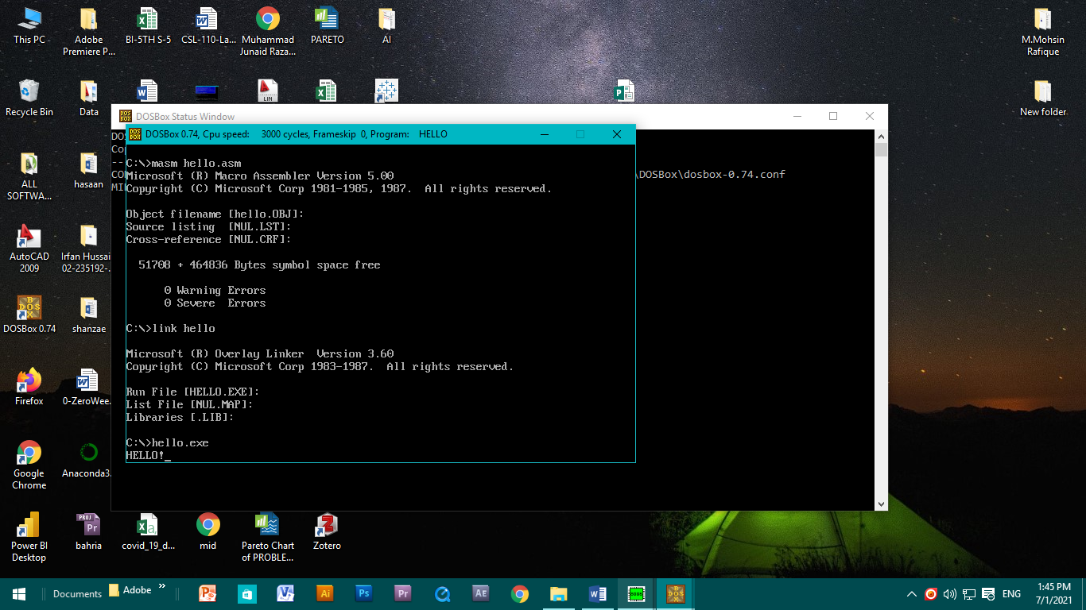

b.

**CMP:** cmp instruction used to compare two statements or registers to follow the loop or conditional statement.

Code:

org 100h

mov ax,3

mov bx,3

**cmp ax,bx**

je ad

sub ax,1

ad:

add ax,bx

ret

